Dr. Wall & Associates
Counseling | Consultation | Professional Development | Clinical Supervision
2825 S. Meridian Road | Suite 150 | Meridian, Idaho 83642
208-297-9495 office | 208-955-2490 fax

April 6, 2020

To Whom It May Concern:
This has been quite the month! At this point every aspect of our lives has been affected by COVID 19. At Dr. Wall & Associates your mental and physical health remain our top priority.
With increasing uncertainty and the growing number of infected individuals around the world and locally, we made the decision to close the office for in-person sessions starting March 16, 2020.
We reevaluate the situation daily and anticipate resuming in-person sessions when schools resume in-person classes and stay-at-home guidelines are lifted.
We know you rely on seeing your counselor (we can imagine not seeing you either!) and many of you have already taken the leap of faith into Telehealth (video visits) with us and we are so thrilled to be offering you uninterrupted counseling services!
For those of you who have not make the switch to telehealth, we do not want you to stop making progress toward your therapeutic goals, and it looks like telehealth may be the “new normal” for quite some time.
I hope you ask your counselor any questions you have about video sessions and let her talk you through the process. Research shows Telehealth sessions are just as effective as in-person appointments. Further, because of the unprecedented nature of this Global Pandemic, most insurance companies are covering Telehealth just like in-person appointments.
Telehealth appointments are completed through the online SimplePractice Client Portal which most of you already use for scheduling, communicating with your counselor, and paying for services. It really is simple! Here is how it works:

- Sign the Telehealth Informed Consent your counselor sends via email
- Prior to each appointment, your counselor will send you a HIPPA protected link to join
- From a private place, using a computer, phone, or tablet, you click on the link
- Your session occurs just like in the office

Jennifer, Caroline, and I are wishing you and yours health during this trying time. We hope to be able to “see” you virtually until we can really see you in the office again. In the meantime, please reach out to the office or your counselor if there is anything you need.

Sincerely,

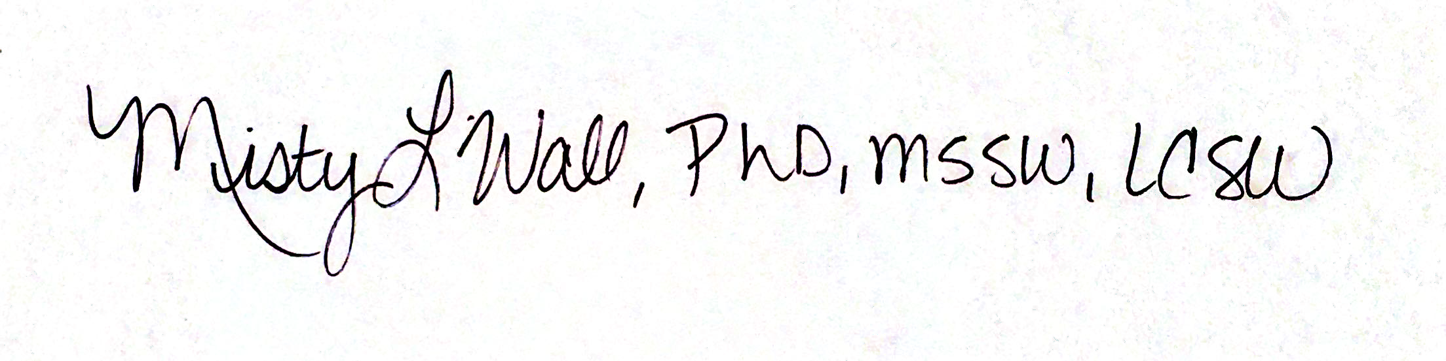

Misty L. Wall, PhD, MSSW, LCSW
Owner, Psychotherapist, Registered Clinical Supervisor

